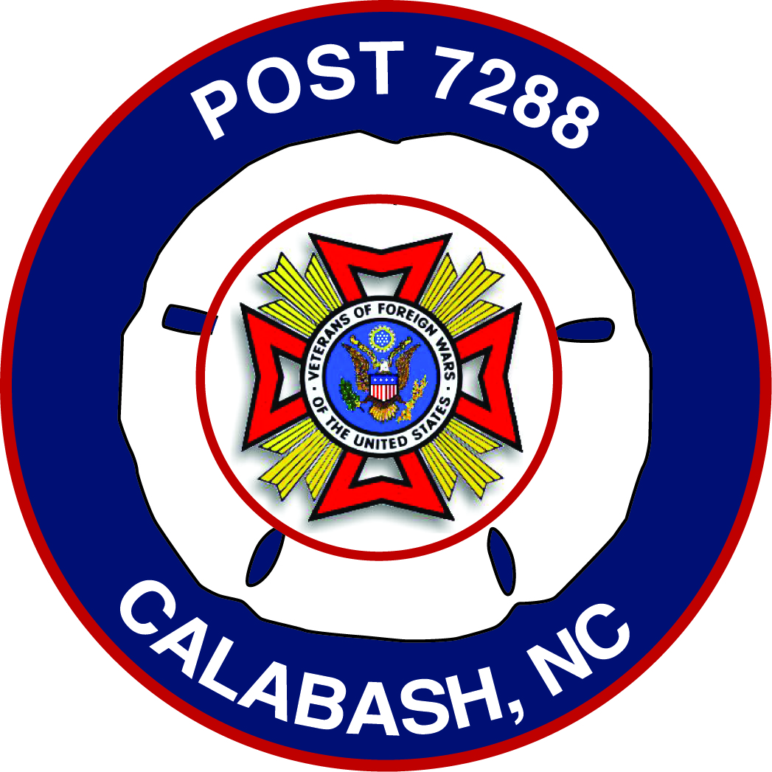
VETERANS OF FOREIGN WARS OF THE UNITED STATES
VFW CALABASH POST #7288

SERVICE OFFICER
Duties and Obligations
Article II, Section 2 of both The By-Laws and the Manual of Procedure of the Veterans of Foreign Wars of the United States (VFW) outlines duties and obligations of VFW Post Officers and Chairman as follows:
Sec. 2. (a) (12) Service Officer. The Post Service Officer shall assist members of the Post, their widows and orphans and other worthy cases brought to their attention in obtaining rightful entitlements from federal and state governments. The work of a Service Officer shall be performed in accordance with the instructions contained in the VFW Guide for Service Officers under the general supervision of the Department Service Officer. He shall perform such other duties as may be incident to the office and as may from time to time be required by the laws and usages of this organization or lawful orders from proper authority.

VFW Calabash Post #7288 Responsibilities
The Service Officer is the liaison for and the interface between veterans and a variety of organizations whose responsibilities are to provide assistance and service to veterans and their families. As Service Officer, contact is made with the following named organizations support veterans and their contact numbers:
- Department of Veterans Affairs (800) 827-1000

- Department of Veterans Transportation Service (910) 488-2120 x7694
(800) 771-6101
- VA Clinic, Supply, NC (910) 754-6141

- Veterans Service Officer, Myrtle Beach, SC Stephen Stevens sssteven58@gmail.com

- Center for Women Veterans http:// www.va.gov/womevets

- VFW Department of Service Officer – Cleo Summers (336) 631-5457

- Department of Brunswick County Veterans Service (910) 253-2233

- Brunswick Family Assistance (910) 754-4766

- Brunswick Senior Resources (910) 754-8776

- Veterans Benefits & Service Booklet

